Configure Auto-Scaling and Load Balancing

Problem Statement:

After deploying an application to ECS Fargate, we must ensure it stays responsive under varying traffic loads. In this lab, you will configure an Application Load Balancer (ALB) to distribute requests across tasks, and set up ECS Service Auto Scaling so the service scales in/out automatically based on CPU utilization. This builds resilience and ensures high availability.

Tools/Software Versions:

1. AWS CLI: v2.28.21

2. ECS Cluster: sample-app-cluster (from Lab 2)

3. ECS Service: sample-app-service (from Lab 2)

4. Container Port: 3000 (Node.js app)

5. Load Balancer: AWS Application Load Balancer (ALB)

6. Auto Scaling: ECS Service Auto Scaling

7. Metrics: Amazon CloudWatch

Hands-on Steps:

Step 1: Create an Application Load Balancer and Target Group

We need a public entry point that spreads requests across ECS tasks.

1. Open EC2 Console → Load Balancers → Create Load Balancer → Application Load Balancer.

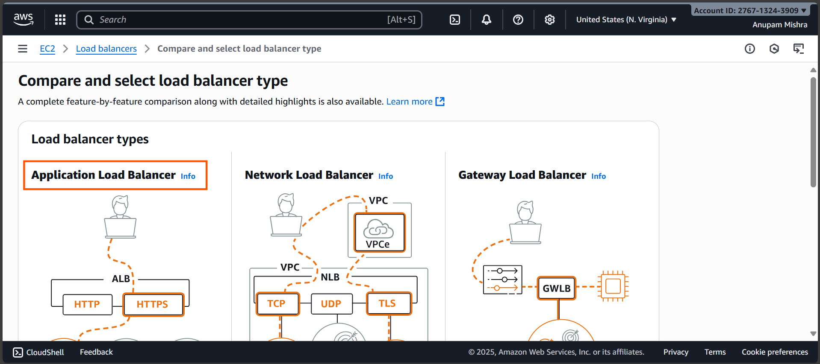

- Load balancer name: sample-app-alb
- Scheme: Internet-facing
- Load balancer IP address type: IPv4
- VPC: Select default VPC
- IP pools: Leave it unchecked (default).
- Availability Zones and subnets: Choose all public subnets in ap-south-1
- Security groups: Create or select one that allows inbound HTTP (port 80) from 0.0.0.0/0.

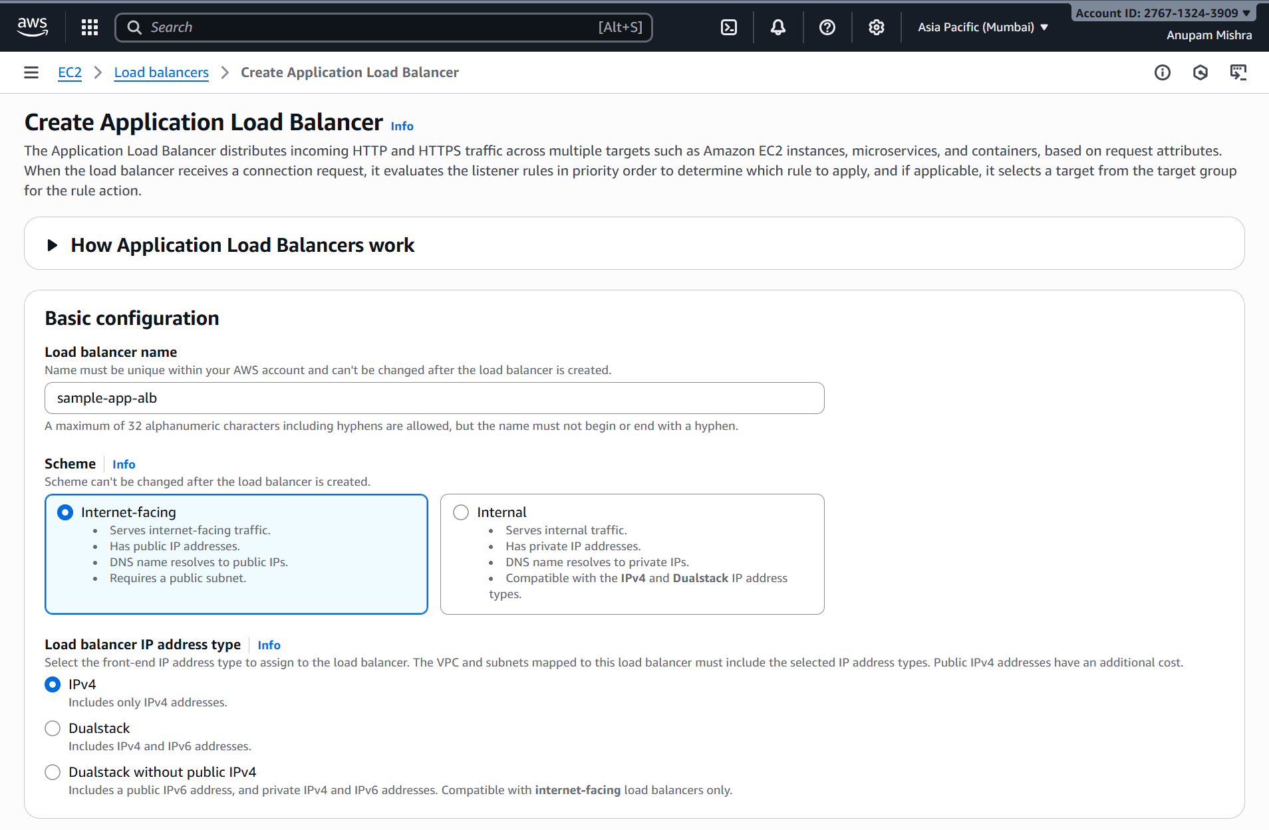
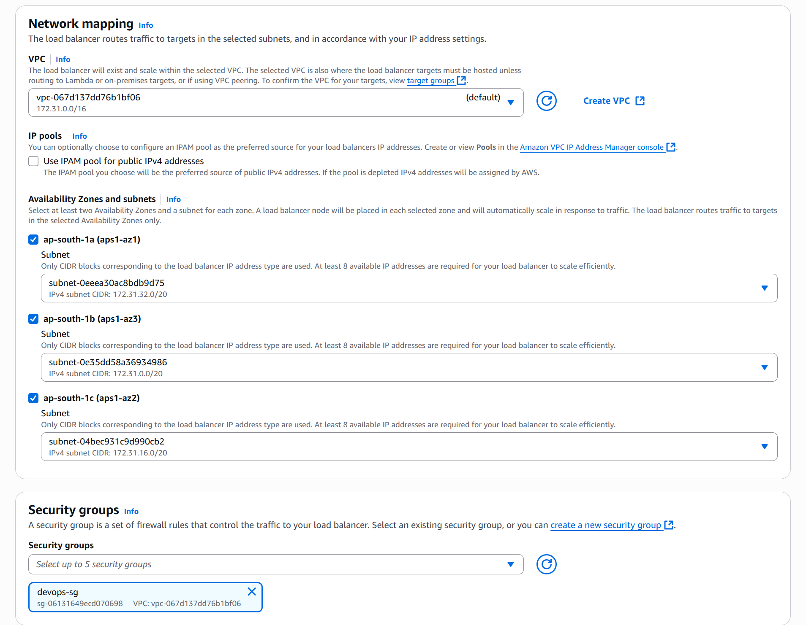

- Listener: HTTP:80

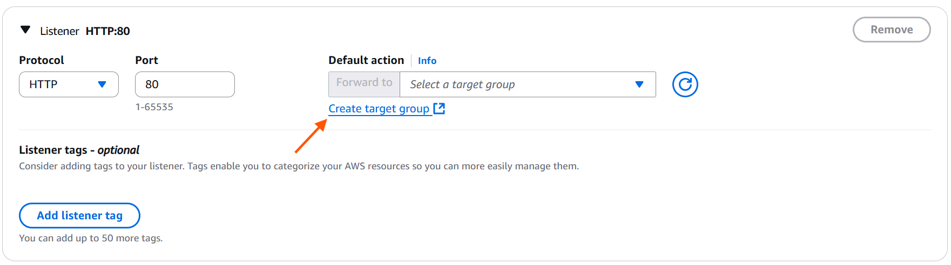

- Default action: Click Create target group.
  - Choose a target type: IP addresses
  - Target group name: sample-app-targets
  - Protocol/Port: HTTP / 3000
  - IP address type: IPv4
  - VPC: default
  - Protocol version: HTTP1
  - Health checks:
    - Protocol: HTTP
    - Path: /health

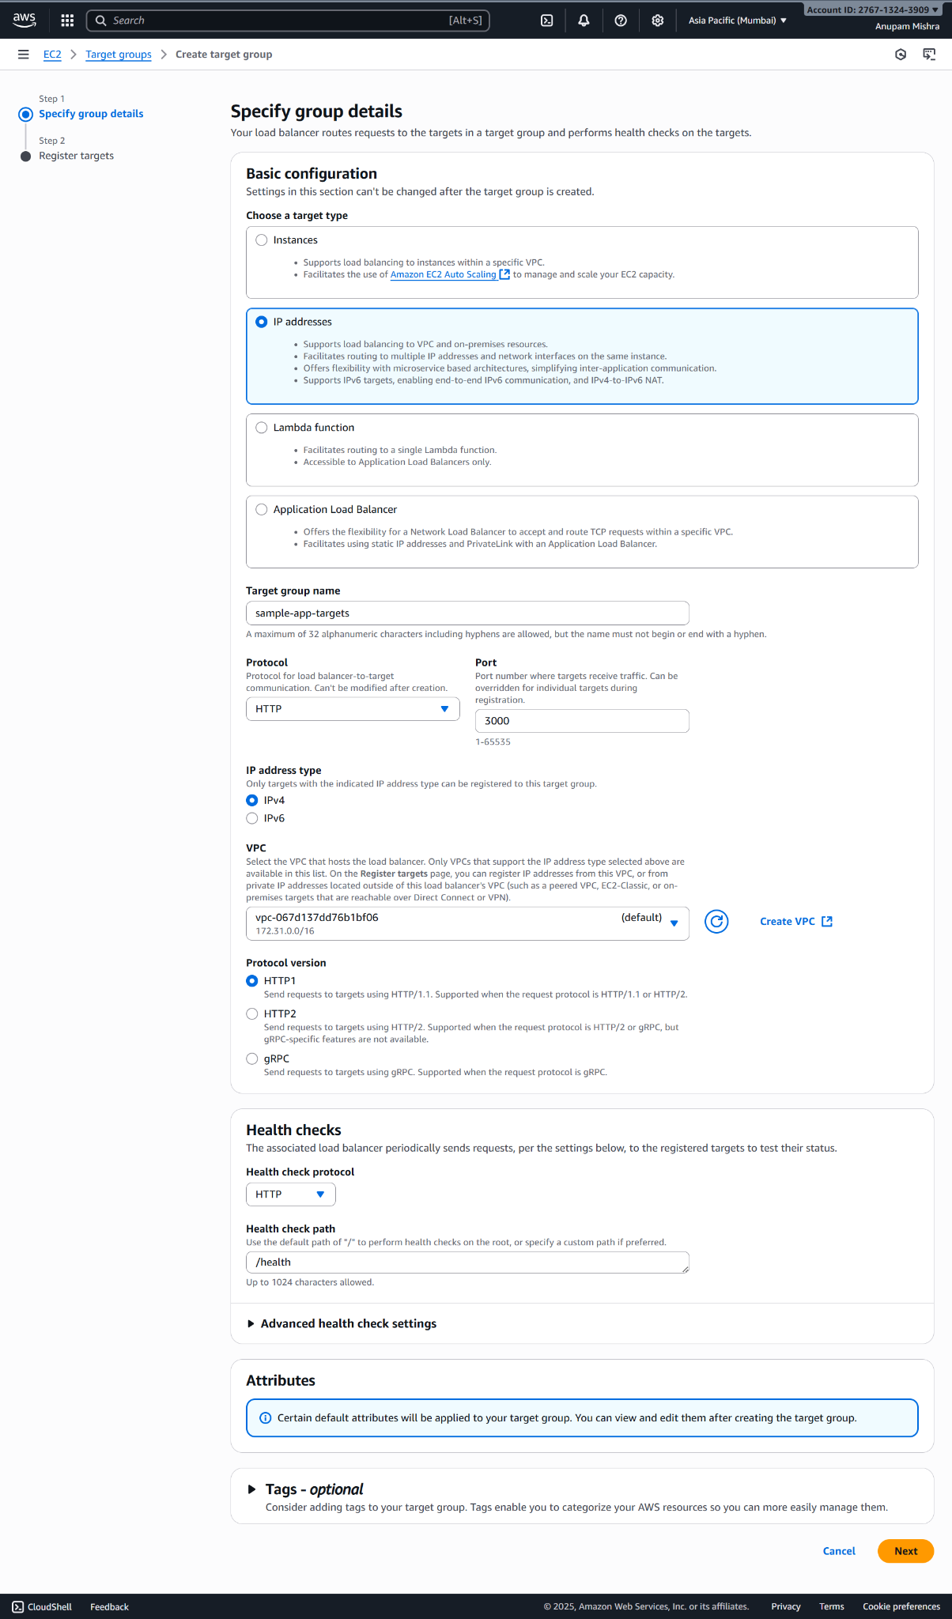

  - Network: vpc-067d137dd76b1bf06 (default)
  - Specify IPs and define ports: Remove 172.31.x.x or click Add IPv4 address.
  - Ports: 3000 (default)
  - Click Create target group.

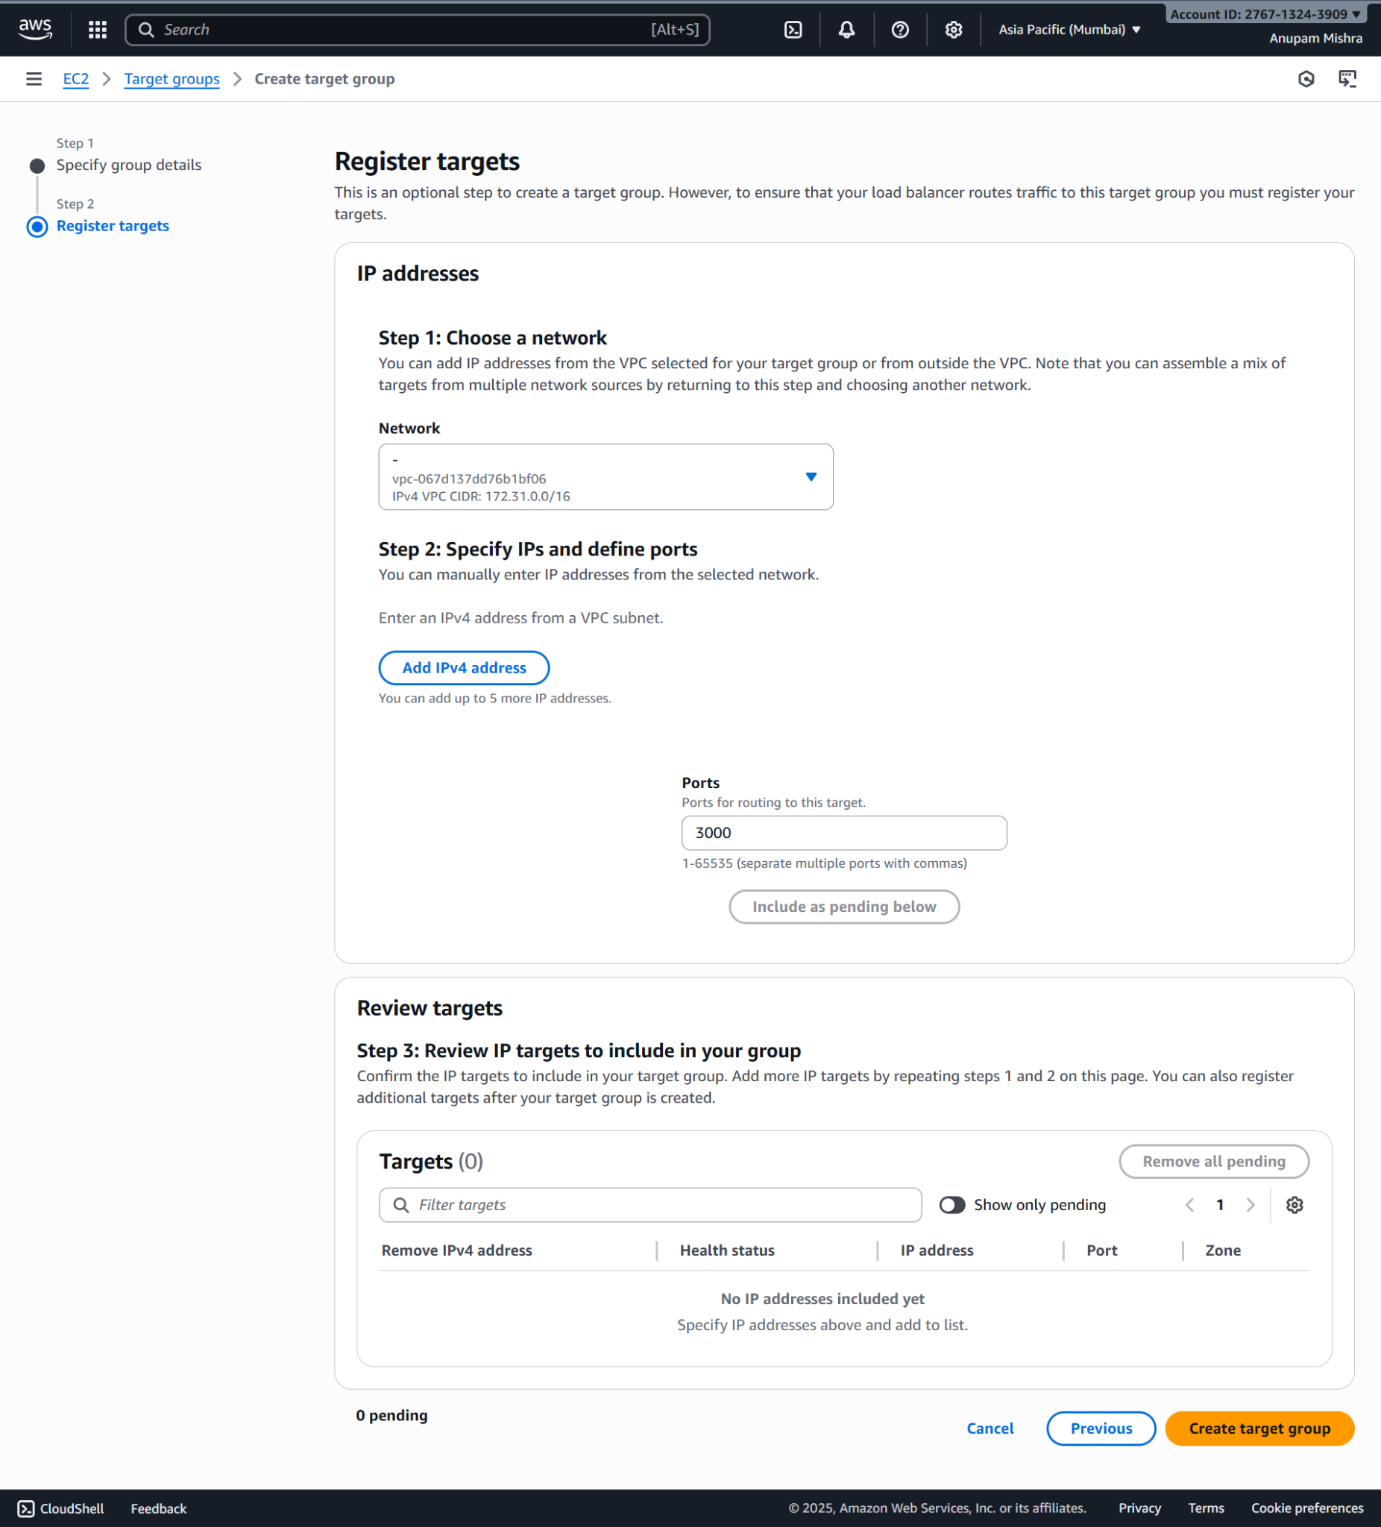

- Add the target group we created to the Default action.

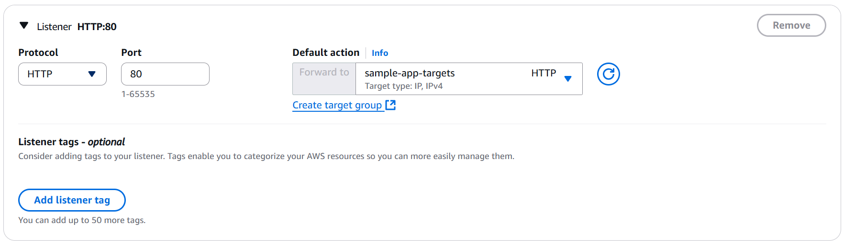

2. Click Create load balancer.

Step 2: Attach Target Group to ECS Service

Now link ECS tasks to the ALB.

1. Open ECS Console → Clusters → sample-app-cluster → Services → sample-app-service → Update service.

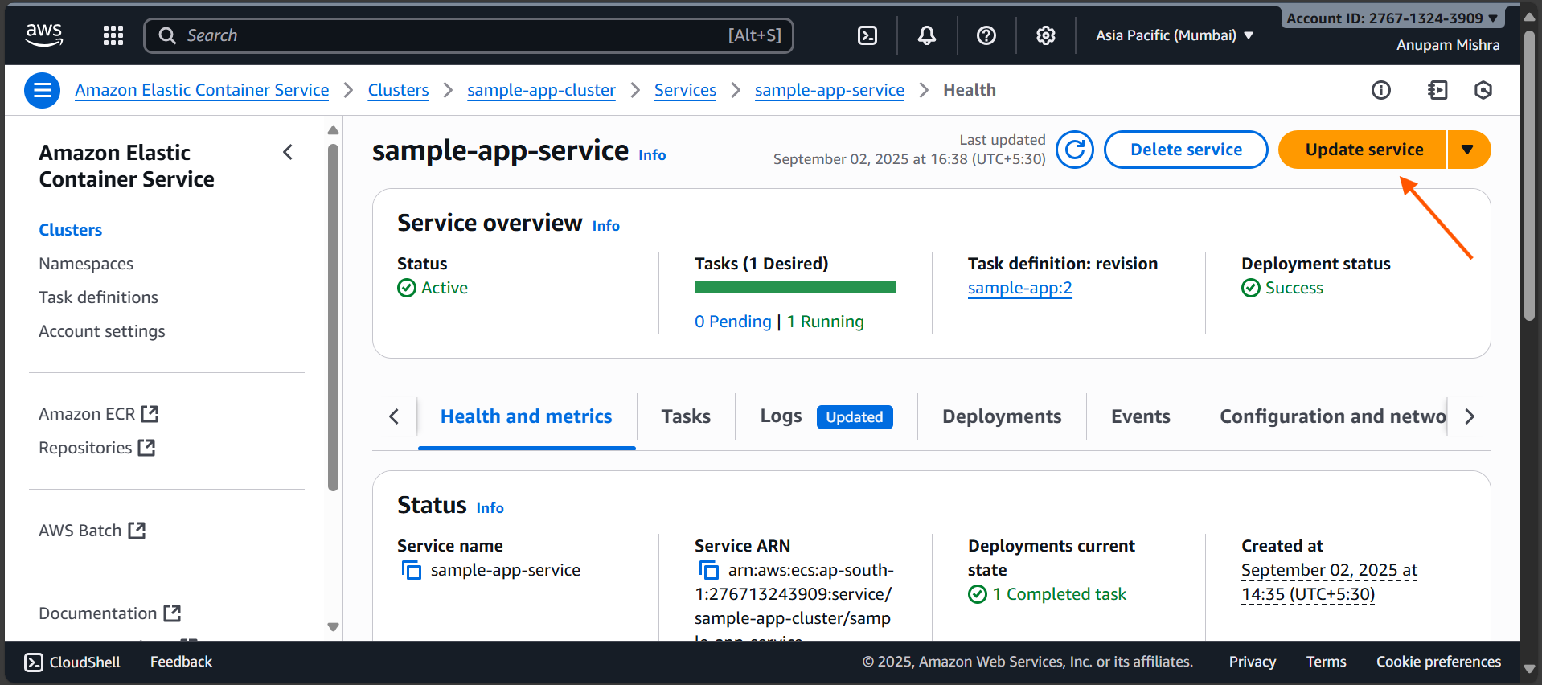

2. Scroll to Load balancing (optional).

- Ensure Use load balancing is checked.
- Select the correct VPC (default).
- Click + Add Load balancer.
- Load balancer type: Application Load Balancer
- Container: sample-app 3000:3000
- Load balancer: sample-app-alb
- Listener: HTTP:80
- Target group: sample-app-targets

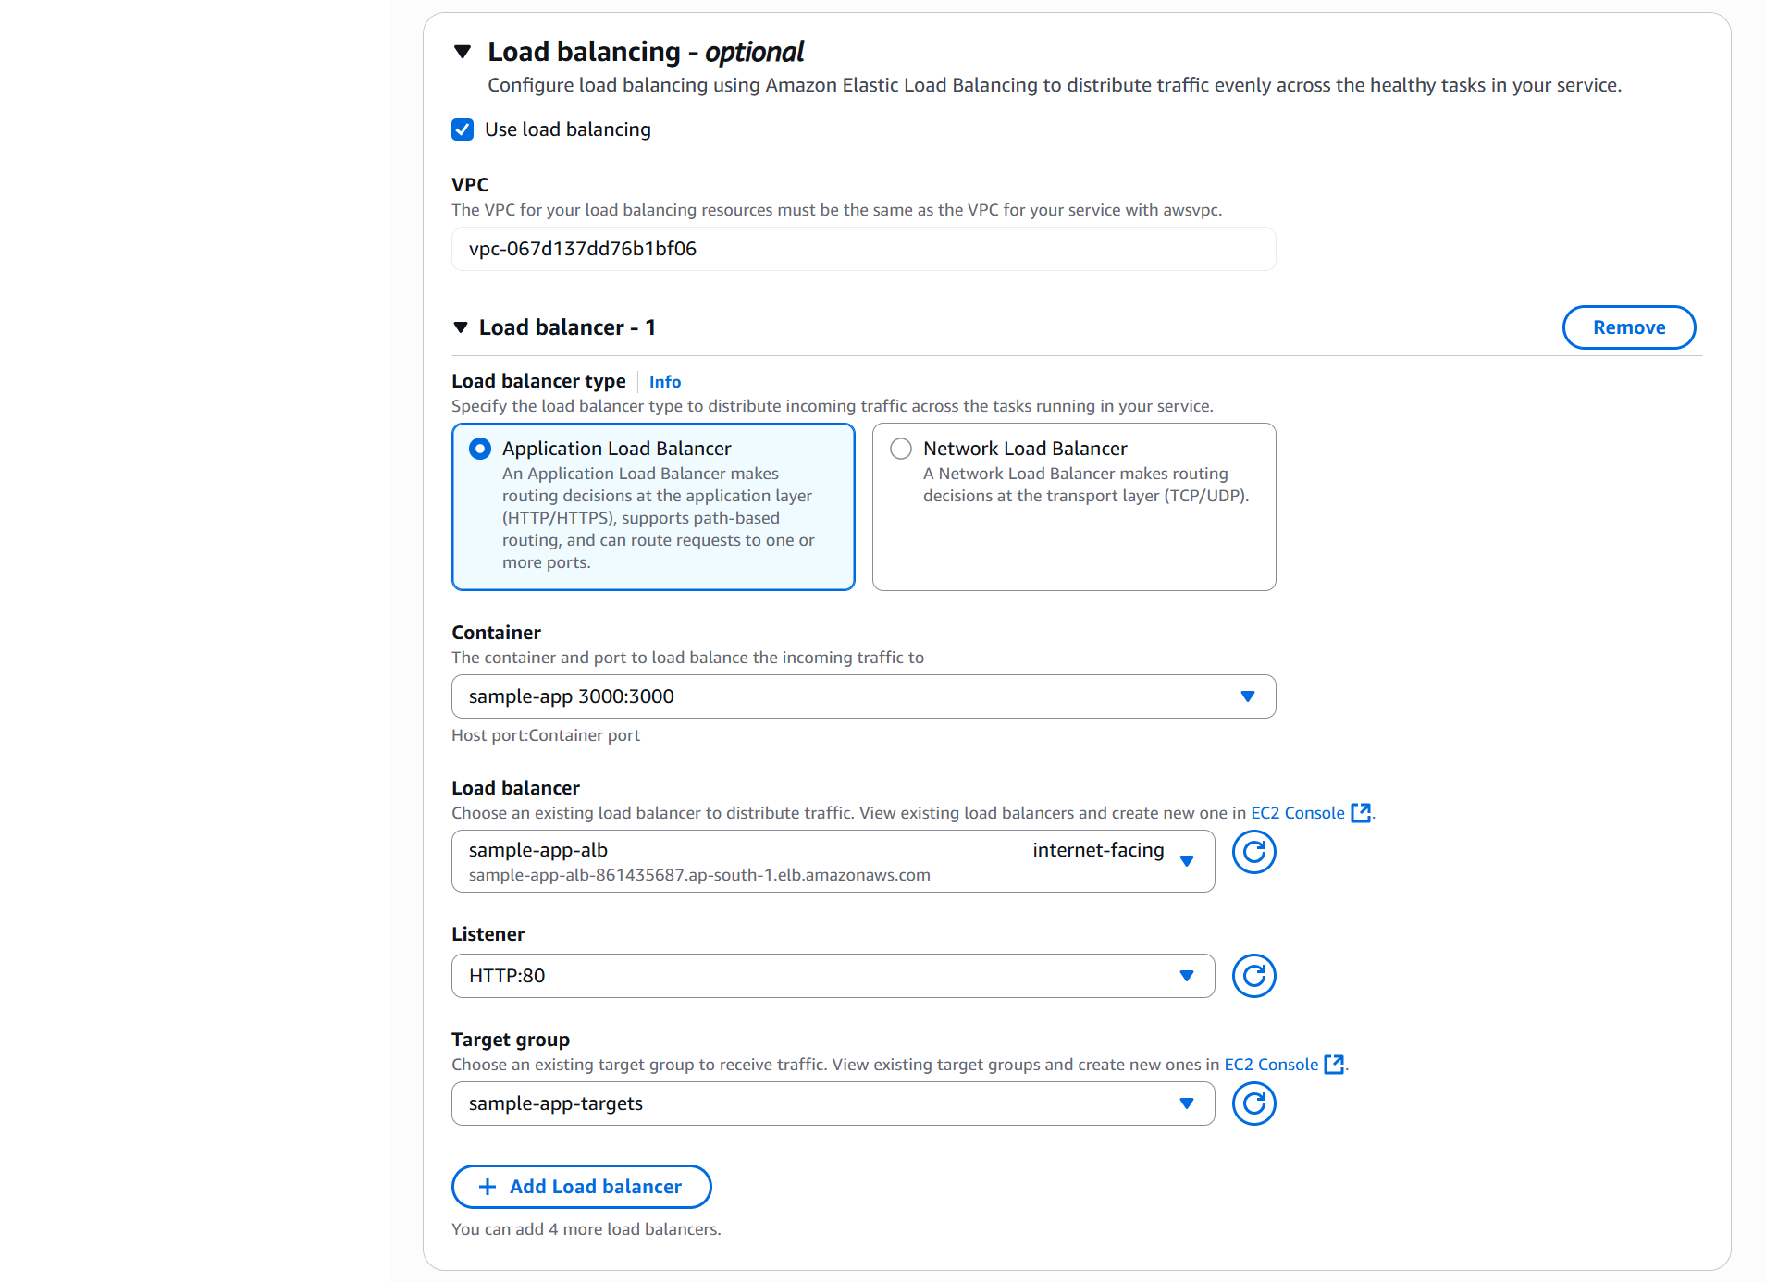

3. Click Update to redeploy the service.

Step 3: Verify Load Balancer Connectivity

Before configuring auto scaling, confirm that the ALB is routing traffic correctly.

1. Go to EC2 Console → Load Balancers → sample-app-alb and copy the DNS name.

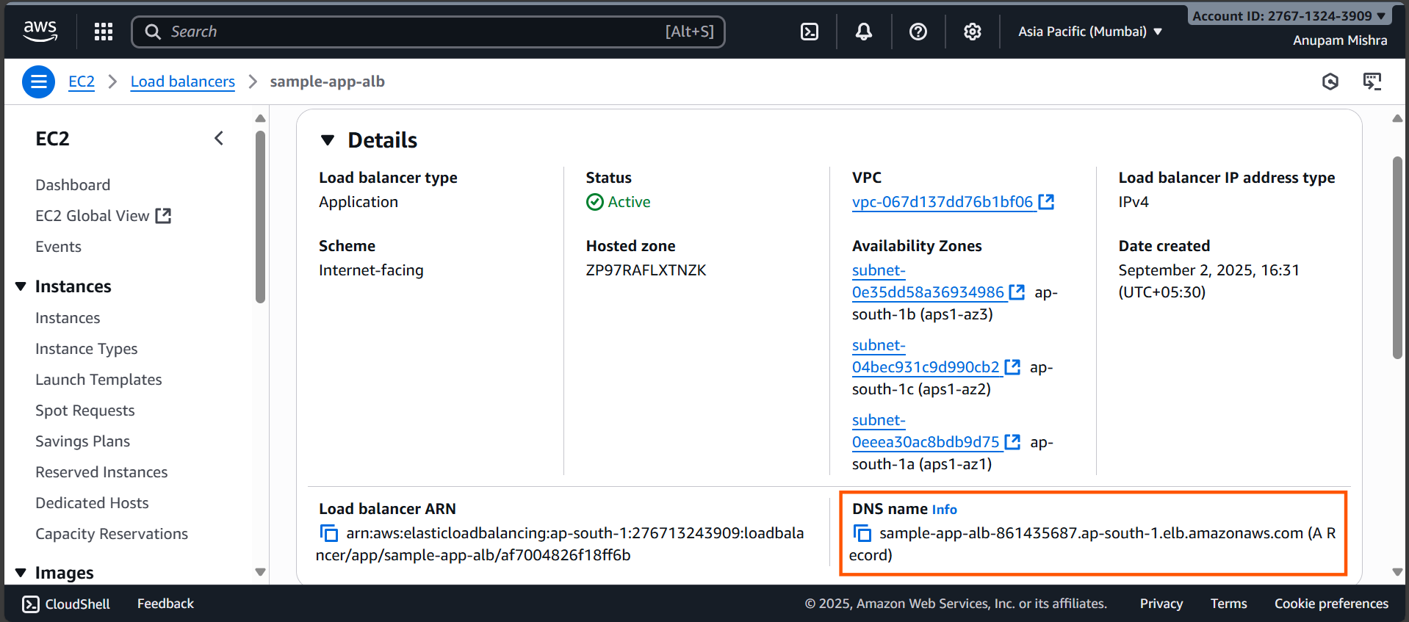

2. Test health endpoint:

curl http://sample-app-alb-861435687.ap-south-1.elb.amazonaws.com/health

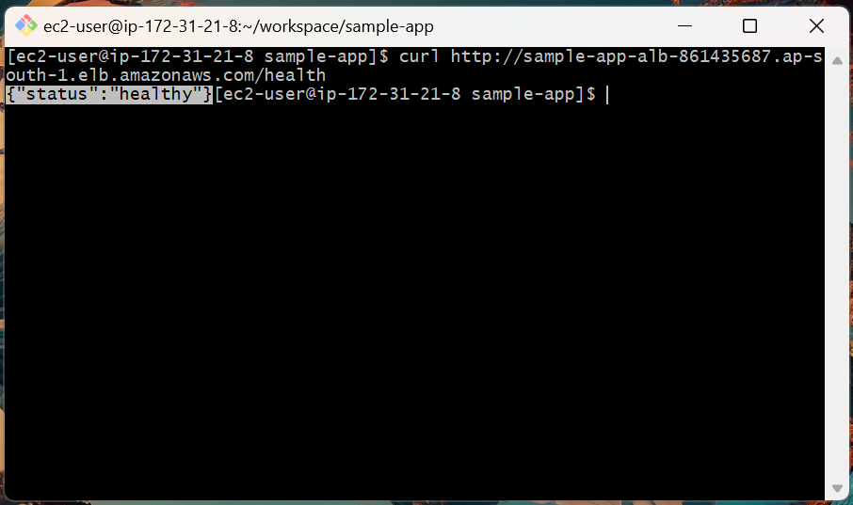

3. Test root endpoint:

curl http://sample-app-alb-861435687.ap-south-1.elb.amazonaws.com/

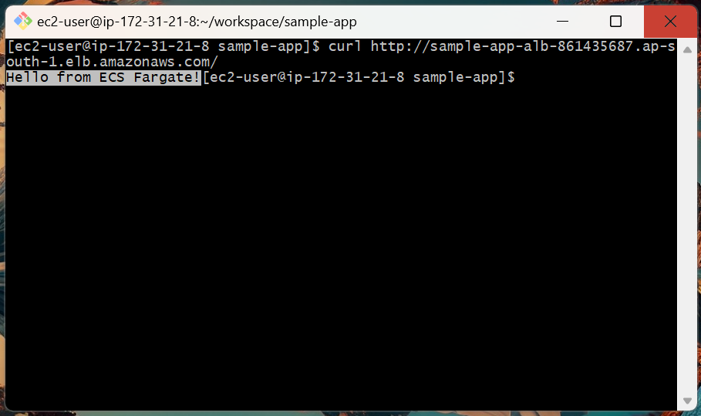

Step 4: Register ECS Service as Scalable Target

We must inform Application Auto Scaling that ECS can adjust the number of tasks.

aws application-autoscaling register-scalable-target \
--service-namespace ecs \
--resource-id service/sample-app-cluster/sample-app-service \
--scalable-dimension ecs:service:DesiredCount \
--min-capacity 1 \
--max-capacity 5 \
--region ap-south-1

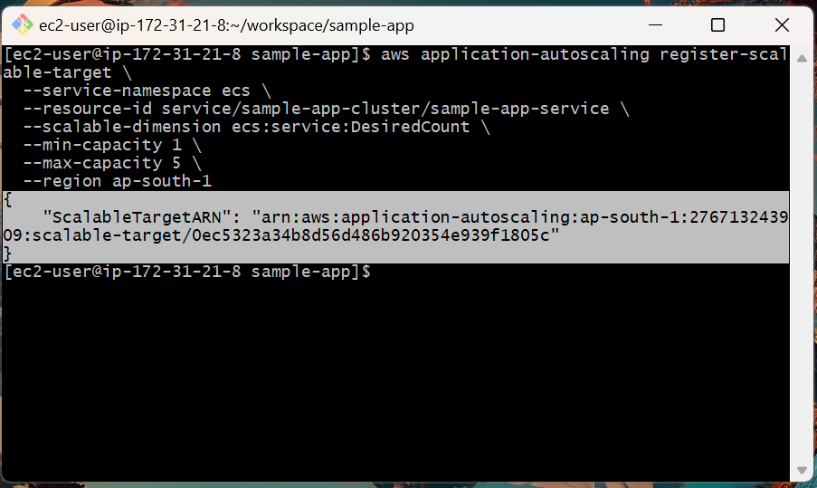

This enables scaling between 1 and 5 tasks for your service.

Step 5: Create Auto Scaling Policies

Define CPU-based scaling behavior with a single TargetTracking policy.

aws application-autoscaling put-scaling-policy \
--service-namespace ecs \
--scalable-dimension ecs:service:DesiredCount \
--resource-id service/sample-app-cluster/sample-app-service \
--policy-name cpu-target-70 \
--policy-type TargetTrackingScaling \
--target-tracking-scaling-policy-configuration \
"TargetValue=70.0,PredefinedMetricSpecification={PredefinedMetricType=ECSServiceAverageCPUUtilization},ScaleOutCooldown=60,ScaleInCooldown=60" \
--region ap-south-1

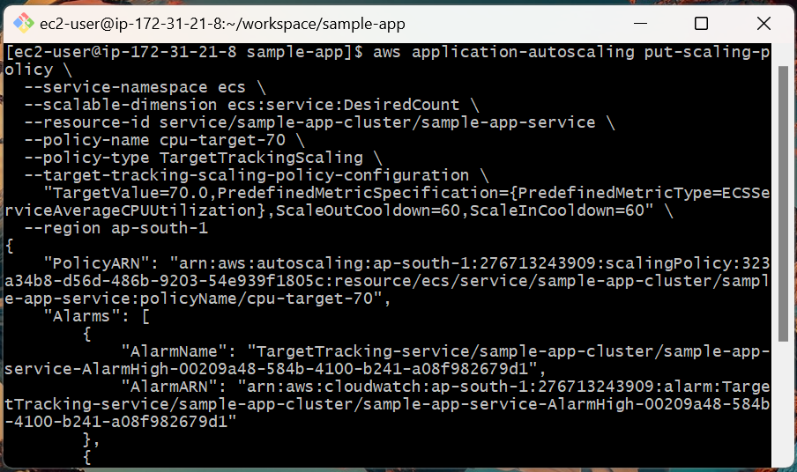

With this one policy:

- ECS scales out when CPU > 70%.
- ECS scales in when CPU < 70%.

Step 6: Test the Setup

1. Get ALB DNS name from EC2 Console → Load Balancers → sample-app-alb.

2. On your EC2 shell, set it once:

ALB_DNS=sample-app-alb-861435687.ap-south-1.elb.amazonaws.com
echo $ALB_DNS

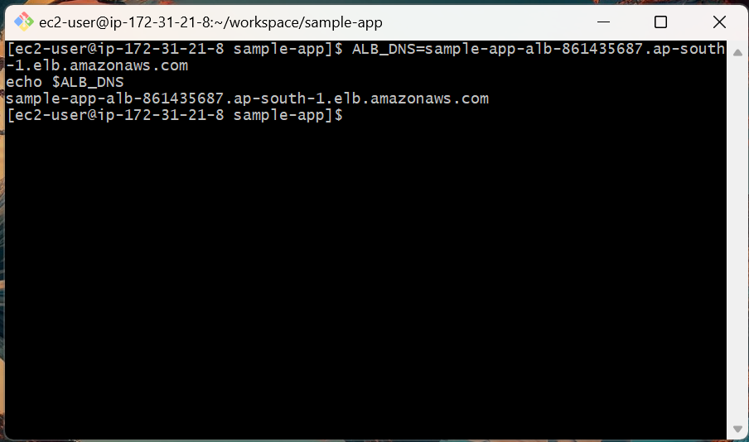

3. Test health endpoint:

curl http://sample-app-alb-861435687.ap-south-1.elb.amazonaws.com/health

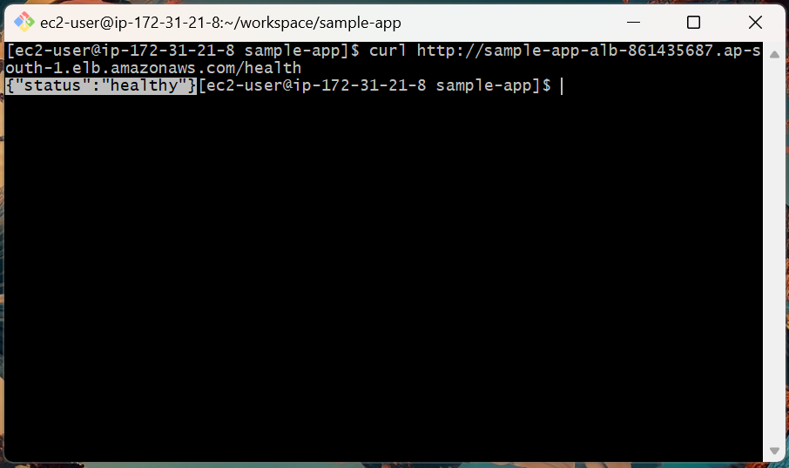

4. Test root endpoint:

curl http://sample-app-alb-861435687.ap-south-1.elb.amazonaws.com/

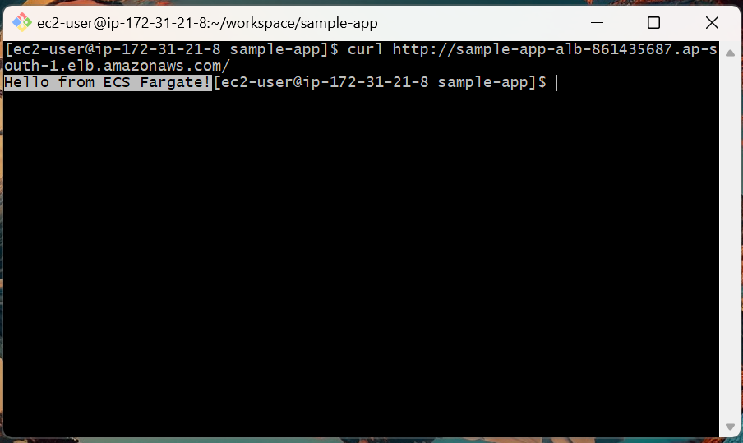

5. Generate load with ApacheBench

We’ll warm up first, then push enough traffic to cross the CPU target.

Warm-up (optional):

ab -n 5000 -c 200 http://sample-app-alb-861435687.ap-south-1.elb.amazonaws.com/

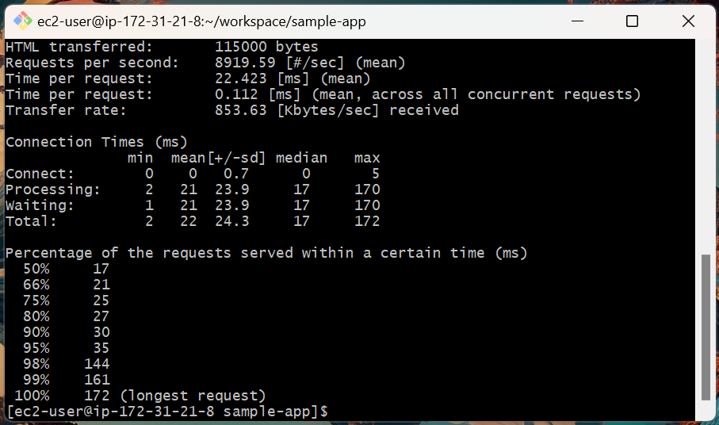

Load test (increase CPU to trigger scale-out):

ab -n 150000 -c 600 http://sample-app-alb-861435687.ap-south-1.elb.amazonaws.com/

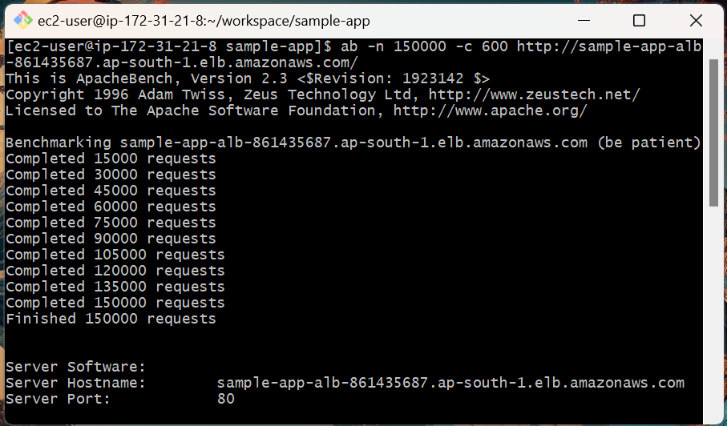

6. Watch ECS Scale Out in Real Time.

Open ECS Console → Clusters → sample-app-cluster → Services → sample-app-service.

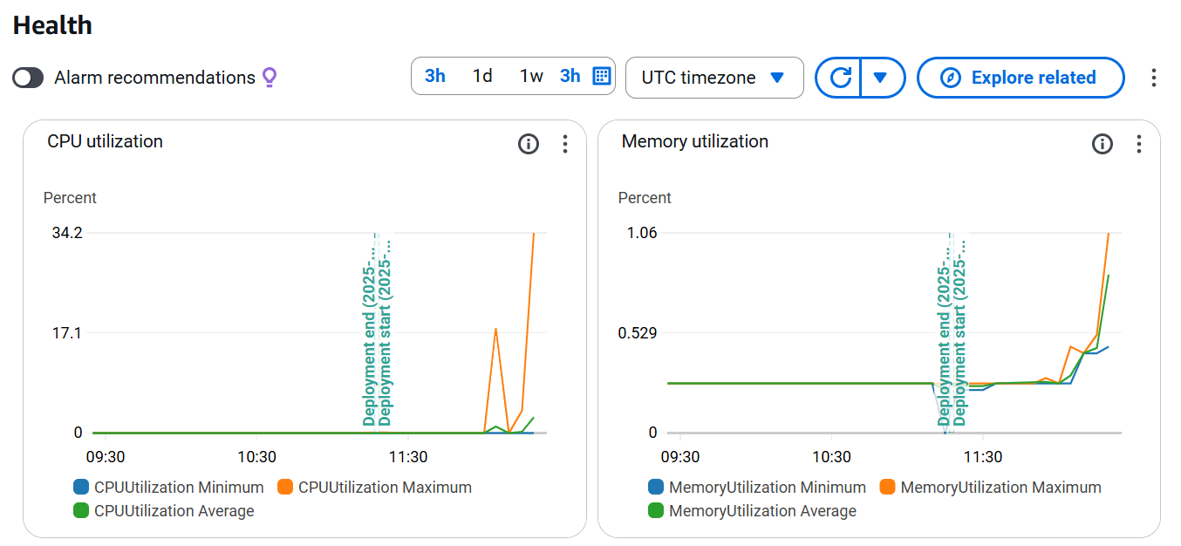

Topics Covered:

1. Configured Application Load Balancer with public access.

2. Created Target Group with health checks.

3. Linked ECS Service with ALB for traffic routing.

4. Configured ECS Service Auto Scaling using one CPU target-tracking policy.

5. Verified scaling behavior with load tests.

